YOUTUBE DATA ANALYSIS DASHBOARD

( USING POWER BI )

1. INTRODUCTION
This project presents a YouTube Data Analysis Dashboard developed using Power BI. The dashboard is designed to analyze and visualize YouTube channel performance data in an interactive and meaningful way. It converts raw data into clear insights that help understand viewer engagement, content performance, and channel growth.
The dashboard provides a user-friendly interface with multiple visualizations, enabling users to explore data efficiently and make informed decisions.
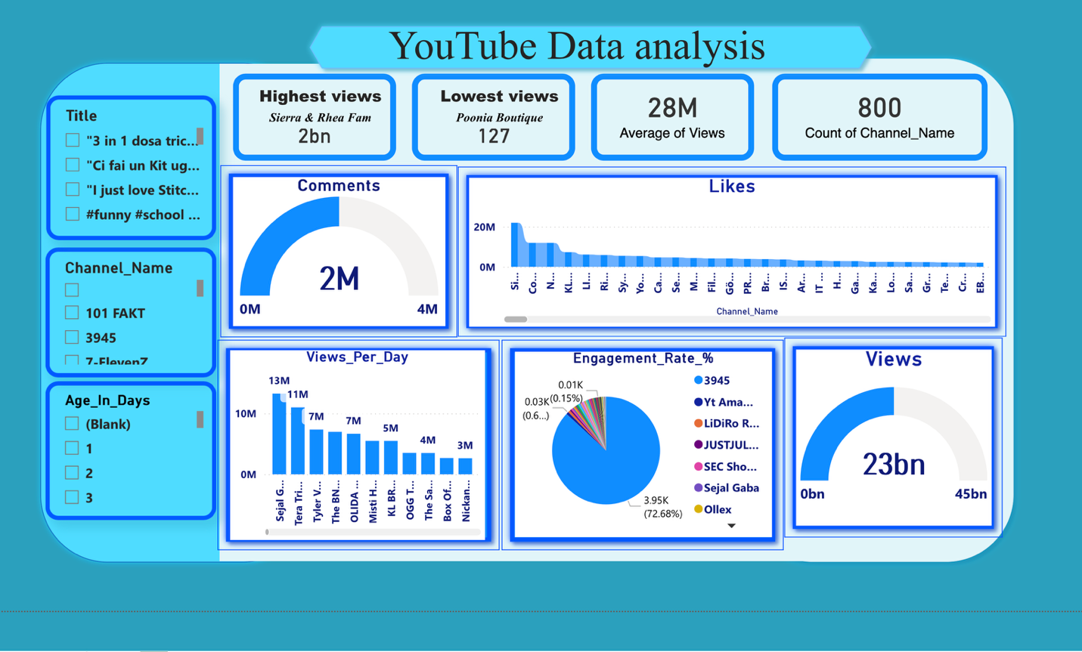

2. OBJECTIVE
The main objectives of this project are:
- To analyze YouTube channel performance data
- To track key metrics such as views, likes, and comments
- To measure audience engagement and content effectiveness
- To compare performance across different channels
- To provide data-driven insights for content strategy improvement

3. TOOLS USED
- Power BI
- Data Visualization Techniques
- Data Cleaning and Transformation (Power Query)
- DAX (Data Analysis Expressions)

4. KEY PERFORMANCE INDICATORS (KPIs)
- Total Views: 23 Billion
- Total Likes: 238 Million
- Average Views: 28 Million
- Total Channels: 800
- Total Comments: 2 Million
These KPIs provide a quick overview of overall YouTube performance.

5. DATA ANALYSIS AND INSIGHTS
5.1 Views Analysis
The dashboard shows total views reaching 23 billion, indicating high audience reach. The views distribution across channels helps identify top-performing creators.
5.2 Likes Analysis
Likes data helps measure audience appreciation. Some channels receive significantly higher likes, indicating strong audience engagement and content quality.
5.3 Comments Analysis
Comments reflect audience interaction. A total of 2 million comments shows active viewer participation and engagement with content.
5.4 Engagement Rate Analysis
The engagement rate helps understand how actively users interact with content. A higher engagement rate indicates better content performance and audience connection.
5.5 Views Per Day Analysis
This metric shows daily performance trends of channels. It helps identify consistent performers and trending content creators.
5.6 Channel-wise Performance
Different channels show varying levels of performance in terms of views, likes, and engagement. This helps in benchmarking and comparison.

6. DASHBOARD FEATURES
- Interactive filters (Channel Name, Title, Age in Days)
- Multiple visualizations (Bar Chart, Pie Chart, Gauge, Line Chart)
- Real-time data interaction
- Clean and structured layout
- Easy-to-understand insights

7. ADVANTAGES
- Simplifies complex YouTube data
- Provides quick insights into channel performance
- Helps content creators improve strategies
- Supports data-driven decision-making
- Enhances visualization and reporting

8. Content Improvement Solutions
- Focus on Emotional & Relatable Content
The highest viewed video (“Sister love”) shows that emotional and relatable content attracts more audience.
Content based on relationships, feelings, and real-life situations performs better.
- Avoid Unclear or Random Content Topics
The lowest viewed content has no clear meaning or target audience.
Content should be simple, clear, and easy to understand.
- Use Proper Titles and Keywords
Clean and meaningful titles improve reach and visibility.
Avoid using unnecessary numbers, symbols, or too many hashtags.
- Create Engaging Short-Form Content
Short videos with strong openings attract more viewers.
The first few seconds should grab audience attention quickly.
- Understand Audience Interest
Analyzing audience preference helps in creating better content.
Posting content based on audience interest increases engagement and views.
9. Conclusion
The analysis shows that content performance mainly depends on clarity, emotional connection, and audience relevance.
Videos like “Sister love” perform better because they are relatable and engaging, while unclear and random content results in low views.
By focusing on quality content, proper titles, and audience interests, creators can significantly improve their performance and reach.
Overall, data-driven content strategy is essential for achieving higher views and engagement on YouTube.

10. FUTURE ENHANCEMENTS
- Real-time data integration using APIs
- Advanced analytics using AI/ML
- Predictive analysis for video performance
- More detailed audience demographics
- Integration with other platforms

